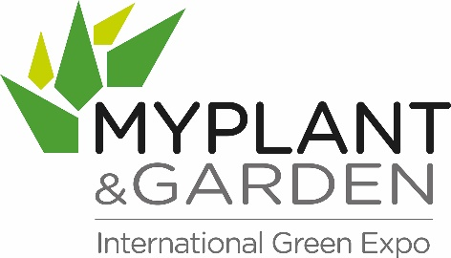
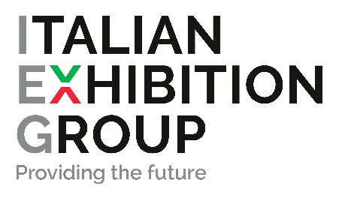

press release
(English translation)

TRADE SHOWS: ITALIAN EXHIBITION GROUP ACQUIRES A MAJORITY SHARE OF V GROUP,
THE COMPANY THAT ORGANISES MYPLANT & GARDEN

- Valeria Randazzo will continue to lead the company as its CEO
- The trade show will still be held at Fiera Milano Rho
- In November, Italian Exhibition Group will present a business development plan for participating companies in synergy with its outdoor contract trade shows.

Rimini, 21/06/2022 - IEG - Italian Exhibition Group S.p.A. has acquired 75% of shares in V Group Srl, the company that organises the Myplant & Garden trade show.

Myplant & Garden, established in 2015, is the most important horticultural, floricultural, landscape and garden trade show event in Italy and a leading European reference point. The exhibition hosts companies operating in the horticultural-floricultural and gardening sector, highlighting the value of green areas for the quality of life, climate, health and well-being inside and outside the home and urban environments. Values that have been rediscovered in recent years, with a growing demand for well-kept outdoor spaces for everyday living. Myplant & Garden promotes green culture, the circular economy, environmental protection and green area design.

IEG’s acquisition will not change the company’s governance: Valeria Randazzo, creator of the show and its ‘organisational soul’, will still act as CEO. The agreement aims to promote and enhance the managerial and operational autonomy of those who have earned Myplant & Garden a position of absolute prominence. The event will continue to be held in the halls of Fiera Milano Rho in the coming years.

By becoming part of such a large group as IEG, leader in the organisation of trade show and congress events, will allow Myplant & Garden to accelerate its growth rate on the international scene and further consolidate its Italian leadership, thanks to investment in innovative initiatives, partnerships and new markets.

“This is a strategic acquisition that further enriches IEG's exhibition calendar,” says Lorenzo Cagnoni, President of the Rimini-based company. “The aim is to generate new development horizons for companies. We will create new prospects for events connected to this business. We are perfecting a development project that will find mutual points of synergy between Myplant & Garden operators and some of our outdoor contract exhibitions. The plan will come into effect in 2023 and we will be presenting it in detail next November.”

“Proud of what has been done so far for the entire sector,” commented Valeria Randazzo, “I am delighted that IEG, a major international player in the trade show world, has decided to invest in the event’s future, guaranteeing continuity to the whole team as well as the growth projects that have been enacted. The opportunities deriving from the agreement will allow Myplant to make yet a further leap in quality.”
The next edition of MyPlant & Garden is therefore scheduled to take place in the Fiera Milano Rho halls from 22nd to 24th February 2023 in the wake of the extraordinarily positive figures registered at last February's edition: 45,000 square metres of exhibition space; 18,500 trade visitors of whom 20% came from abroad; 116 official buyer delegations from thirty countries.

At the same time, the Myplant & Garden Consortium, formed by a group of companies representing the green supply chains that have supported the event since its inception, has undergone a change in top management with Marco Orlandelli now as the new president, taking over from Gianpietro D'Adda, who had been in office since 2015.

FOCUS ON ITALIAN EXHIBITION GROUP
Italian Exhibition Group S.p.A., a joint stock company listed on Euronext Milan, a regulated market organised and managed by Borsa Italiana S.p.A., has, with its facilities in Rimini and Vicenza, achieved national leadership over the years in the organisation of trade shows and conferences. The development of activities abroad - also through joint-ventures with global or local organisers, in the United States, United Arab Emirates, China, Mexico, Brazil and India, for example – now sees the company positioned among the top European operators in the sector.

This press release contains forecast elements and estimates that reflect the management’s current opinions (“forward-looking statements”), particularly regarding future management performance, realization of investments, cash flow trends and the evolution of the financial structure. For their very nature, forward-looking statements have a component of risk and uncertainty, as they depend on the occurrence of future events. The effective results may differ (even significantly) from those announced, due to numerous factors, including, only by way of example: food service market and tourist flow trends in Italy, gold and jewellery market trends, green economy market trends; the evolution of raw material prices; general macroeconomic conditions; geopolitical factors and evolutions in the legislative framework. Moreover, the information contained in this release, does not claim to be complete, and has not been verified by independent third parties. Forecasts, estimates and objectives contained herein are based on the information available to the Company as at the date of this release.

